FINRL research notes

# Financial mesurement

### The sharpe ratio

* Definition: **Sharpe ratio** is the measure of risk-adjusted return of a financial portfolio. A portfolio with a higher Sharpe ratio is considered superior relative to its peers. The measure was named after William F Sharpe, a Nobel laureate and professor of finance, emeritus at Stanford University.
* **Description**: Sharpe ratio is a measure of excess portfolio return over the risk-free rate relative to its standard deviation. Normally, the 90-day Treasury bill rate is taken as the proxy for risk-free rate.
* **The risk free rate:**
  + The risk-free rate of return refers to the theoretical rate of return of an investment with zero risk.
  + In practice, the risk-free rate of return does not truly exist, as every investment carries at least a small amount of risk.
  + To calculate the real risk-free rate, subtract the inflation rate from the yield of the Treasury bond matching your investment duration.
  + In theory, the risk-free rate is the minimum return an investor expects for any investment because he will not accept additional risk unless the potential rate of return is greater than the risk-free rate.
* Subtracting the risk-free rate from the mean return allows an investor to better isolate the profits associated with risk-taking activities. [The risk-free rate of return](https://www.investopedia.com/articles/financial-theory/08/risk-free-rate-return.asp) is the return on an investment with zero risk, meaning it's the return investors could expect for taking no risk. The yield for a U.S. Treasury bond, for example, could be used as the risk-free rate.
  + The Sharpe ratio adjusts a portfolio’s past performance—or expected future performance—for the excess risk that was taken by the investor
  + A high Sharpe ratio is good when compared to similar portfolios or funds with lower returns.
  + The Sharpe ratio has several weaknesses, including an assumption that investment returns are normally distributed.
* 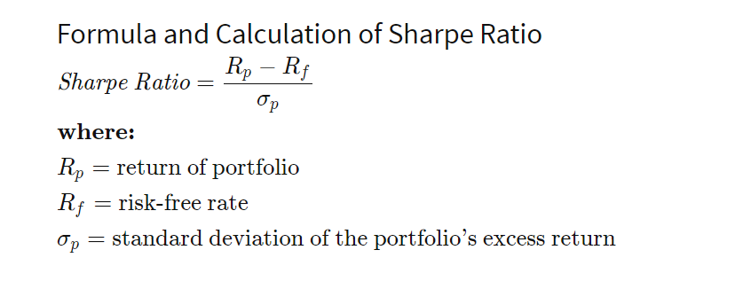

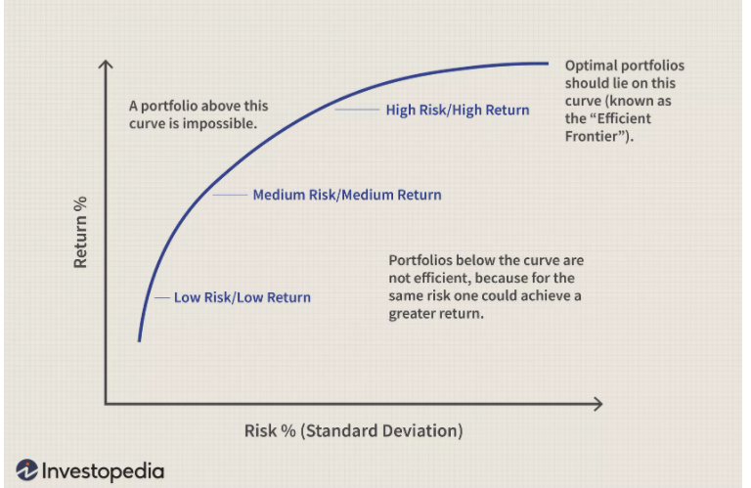

# Terminologies

* What is stock?
  + [Stock Definition (investopedia.com)](https://www.investopedia.com/terms/s/stock.asp)
* **Interest rate**:
  + The interest rate is the amount charged on top of the principal by a lender to a borrower for the use of assets.
  + A loan that is considered low risk by the lender will have a lower interest rate. A loan that is considered high risk will have a higher interest rate.
* **Market friction**: Market friction is anything which prevents a trade from being executed smoothly, in layman terms. It could mean any reason which influences the process of decision-making of the investor.
  + The prices of stocks are fluid and constantly changing; the price quoted for a stock at any point throughout the day is simply the price that paid the last time that stock was traded
  + News about a company can be released while the market is closed, shifting what investors are willing to pay to own a share of the company and changing the price of the company's stock without any trades occurring.
  + The listed **closing price** is the last price anyone paid for a share of that stock during the business hours of the exchange where the stock trades. The **opening price** is the price from the first transaction of a business day. Sometimes these prices are different. During a regular trading day, the balance between supply and demand fluctuates as the attractiveness of the stock's price increases and decreases. These fluctuations are why closing and [opening prices](https://www.investopedia.com/terms/o/openingprice.asp) are not always identical. In the hours between the [closing bell](https://www.investopedia.com/terms/c/closingbell.asp) and the following trading day's [opening bell](https://www.investopedia.com/terms/o/openingbell.asp), a number of factors can affect the attractiveness of a particular stock.
* **Equilibrium** is the state in which market supply and demand balance each other, and as a result prices become stable. Generally, an over-supply of goods or services causes prices to go down, which results in higher demand—while an under-supply or shortage causes prices to go up resulting in less demand. The balancing effect of supply and demand results in a state of equilibrium.
* **Volatility** represents how large an asset's prices swing around the mean price - it is a statistical measure of its dispersion of returns.
  + There are several ways to measure volatility, including beta coefficients, option pricing models, and standard deviations of returns.
  + Volatile assets are often considered riskier than less volatile assets because the price is expected to be less predictable.
  + Volatility is an important variable for calculating options prices.
* **Liquidity** refers to the efficiency or ease with which an [asset](https://www.investopedia.com/terms/a/asset.asp) or [security](https://www.investopedia.com/terms/s/security.asp) can be converted into ready cash without affecting its [market price](https://www.investopedia.com/terms/m/market-price.asp). The most liquid asset of all is cash itself
  + Liquidity refers to the ease with which an asset, or security, can be converted into ready cash without affecting its market price
  + Cash is the most liquid of assets while tangible items are less liquid. The two main types of liquidity include market liquidity and accounting liquidity.
  + Current, quick, and cash ratios are most commonly used to measure liquidity
* **Options** are [financial instruments](https://www.investopedia.com/terms/f/financialinstrument.asp) that are [derivatives](https://www.investopedia.com/terms/d/derivative.asp) based on the value of underlying securities such as stocks. An options contract offers the buyer the opportunity to buy or sell—depending on the type of contract they hold—the underlying asset. [Unlike futures](https://www.investopedia.com/ask/answers/difference-between-options-and-futures/), the holder is not required to buy or sell the asset if they choose not to.
  + [Call options](https://www.investopedia.com/terms/c/call.asp) allow the holder to buy the asset at a stated price within a specific timeframe.
  + [Put options](https://www.investopedia.com/terms/p/put.asp) allow the holder to sell the asset at a stated price within a specific timeframe.
  + Each option contract will have a specific expiration date by which the holder must exercise their option. The stated price on an option is known as the strike price. Options are typically bought and sold through [online or retail brokers](https://www.investopedia.com/best-brokers-for-options-trading-4587876).
* **Cherry picking** involves choosing investments by following other investors and institutions that are considered reliable and successful.
  + Cherry picking doesn't involve research but instead, involves using the research of other reliable sources.
  + Cherry-picking is also defined as the fraudulent practice of investment managers allocating winning trades to their personal accounts or to favored clients.
* A **trading platform** is software used for trading: opening, closing, and managing market positions through a financial intermediary such as an online broker. Online trading platforms are frequently offered by brokers either for free or at a discount rate in exchange for maintaining a funded account and/or making a specified number of trades per month.
  + A trading platform is the software that enables investors and traders to place trades and monitor accounts through financial intermediaries. Oftentimes, trading platforms will come bundled with other features, such as real-time quotes, charting tools, news feeds, and even premium research. Platforms may also be specifically tailored to specific markets, such as stocks, [currencies](https://www.investopedia.com/terms/c/currency.asp), options, or [futures](https://www.investopedia.com/terms/f/futures.asp) markets.
* **Equity** represents the value that would be returned to a company’s shareholders if all of the assets were liquidated and all of the company's debts were paid off.
  + We can also think of equity as a degree of residual ownership in a firm or asset after subtracting all debts associated with that asset.
  + The calculation of equity is a company's total assets minus its total liabilities, and is used in several key financial ratios such as ROE.
  + Shareholders’ Equity=Total Assets−Total Liabilities
* **Annual return:** The yearly rate of return method, commonly referred to as the [annual percentage rate](https://www.investopedia.com/terms/a/apr.asp), is the amount earned on a fund throughout an entire year. The yearly rate of return is calculated by taking the amount of money gained or lost at the end of the year and dividing it by the initial investment at the beginning of the year. This method is also referred to as the annual rate of return or the nominal annual rate.
* **Portfolio:** 
  + A portfolio is a collection of financial investments like stocks, bonds, commodities, cash, and cash equivalents, as well as their fund counterparts.
  + Stocks and bonds are generally considered a portfolio's core building blocks, though you may grow a portfolio with many different types of assets—including real estate, gold, paintings, and other art collectibles.
  + Diversification is a key concept in portfolio management
  + A person's tolerance for risk, investment objectives, and time horizon are all critical factors when assembling and adjusting an investment portfolio.
* **Blue chip**:
  + A blue chip refers to an established, stable, and well-recognized corporation.
  + Blue-chip stocks are seen as relatively safer investments, with a proven track record of success and stable growth
  + Blue-chip stocks are still nonetheless subject to volatility and failure, such as with the collapse of Lehman Brothers or the impact of the financial crisis on General Motors
  + The name "blue chip" came about from the game of poker in which the blue chips have the highest value\
* **Public trade company**:
  + A public company—also called a publicly traded company—is a corporation whose shareholders have a claim to part of the company's assets and profits.
  + Ownership of a public company is distributed among general public shareholders through the free trade of shares of stock on stock exchanges or over-the-counter (OTC) markets.
  + In addition to its securities trading on public exchanges, a public company is also required to disclose its financial and business information regularly to the public
* **Market capitalization**:
  + Market capitalization refers to how much a company is worth as determined by the stock market. It is defined as the total market value of all outstanding shares.
  + To calculate a company's market cap, multiply the number of outstanding shares by the current market value of one share.
  + Companies are typically divided according to market capitalization: large-cap ($10 billion or more), mid-cap ($2 billion to $10 billion), and small-cap ($300 million to $2 billion).
  + Understanding what a company is worth is an important task, and often difficult to quickly and accurately ascertain. Market capitalization is a quick and easy method for estimating a company's value by **extrapolating what the market thinks it is worth for publicly traded companies**. In such a case, simply multiply the share price by the number of available shares.
* **Outstanding shares**:
  + Shares outstanding refer to a company's stock currently held by all its shareholders, including share blocks held by institutional investors and restricted shares owned by the company’s officers and insiders.
  + A company's number of shares outstanding is not static and may fluctuate wildly over time
* When a company went bankrupt, stock holder will be pay nothing.
* Preferred stock:
  + Preferred stockholders have a higher claim on distributions (e.g. dividends) than common stockholders.
  + Preferred stockholders usually have no or limited, voting rights in corporate governance
  + In the event of a liquidation, preferred stockholders claim on assets is greater than common stockholders but less than bondholders
  + Preferred stock has characteristics of both bonds and common stock which enhances its appeal to certain investors.

# Back testing strategies

* Backtesting is the general method for seeing how well a strategy or model would have done [ex-post](https://www.investopedia.com/terms/e/expost.asp). Backtesting assesses the viability of a [trading strategy](https://www.investopedia.com/terms/t/trading-strategy.asp) by discovering how it would play out using historical data. If backtesting works, traders and analysts may have the confidence to employ it going forward.
  + Backtesting assesses the viability of a trading strategy or pricing model by discovering how it would have played out retrospectively using historical data.
  + The underlying theory is that any strategy that worked well in the past is likely to work well in the future, and conversely, any strategy that performed poorly in the past is likely to perform poorly in the future
  + When testing an idea on historical data, it is beneficial to reserve a time period of historical data for testing purposes. If it is successful, testing it on alternate time periods or out-of-sample data can help confirm its potential viability
  + One of the key concepts in [portfolio management](https://www.investopedia.com/terms/p/portfoliomanagement.asp) is the wisdom of [diversification](https://www.investopedia.com/terms/d/diversification.asp)—which simply means not to put all your eggs in one basket. Diversification tries to reduce [risk](https://www.investopedia.com/terms/r/risk.asp#axzz1dgzOuyIo) by allocating investments among various financial instruments, industries, and other categories. It aims to maximize returns by investing in different areas that would each react differently to the same event. There are many ways to diversify. How you choose to do it is up to you. Your goals for the future, your appetite for risk, and your personality are all factors in deciding how to build your portfolio
* **Ex-post** is a word for actual returns and translates from Latin as "after the fact."
  + Ex-post analysis looks at financial results after they have occurred and utilizes them to predict the likelihood of future returns.
* A backtest should consider all **trading costs**, however insignificant, as these can add up over the course of the backtesting period and drastically affect the appearance of a strategy’s profitability. Traders should ensure that their backtesting software accounts for these costs.
* For backtesting to provide meaningful results, traders must develop their strategies and test them in good faith, avoiding bias as much as possible. That means the strategy should be developed without relying on the data used in backtesting.
* That’s harder than it seems. Traders generally build strategies based on historical data. They must be strict about testing with different data sets from those they train their models on. Otherwise, the backtest will produce glowing results that mean nothing
* One way to compensate for the tendency to data dredge or cherry-pick is to use a strategy that succeeds in the relevant, or in-sample, time period and backtest it with data from a different, or out-of-sample, time period. If in-sample and out-of-sample backtests yield similar results, then they are more likely to be proved valid.

**Forward Performance Testing**

* Forward performance testing, also known as [paper trading](https://www.investopedia.com/terms/p/papertrade.asp), provides traders with another set of out-of-sample data on which to evaluate a system. Forward performance testing is a simulation of actual trading and involves following the system's logic in a live market. It is also called paper trading since all trades are executed on paper only; that is, trade entries and exits are documented along with any profit or loss for the system, but no real trades are executed.

### Modern Portfolio Theory

* Modern portfolio theory (MPT) is a theory on how risk-averse investors can construct portfolios to maximize expected return based on a given level of market risk.
* MPT can also be used to construct a portfolio that minimizes risk for a given level of expected return.
* Modern portfolio theory is very useful for investors trying to construct efficient portfolios using ETFs. (exchange traded funds)
* Investors who are more concerned with downside risk than variance might prefer post-modern portfolio theory (PMPT) to MPT.

### Downside risk

* Downside risk is an estimation of a [security's](https://www.investopedia.com/terms/s/security.asp) potential loss in value if market conditions precipitate a decline in that security's price. Depending on the measure used, downside risk explains a worst-case scenario for an investment and indicates how much the investor stands to lose. Downside risk measures are considered [one-sided](https://www.investopedia.com/terms/o/one-tailed-test.asp) tests since the potential for profit is not considered.
* Downside risk is an estimation of a security's potential loss in value if market conditions precipitate a decline in that security's price.